**CHEMISTRY**

**Year 11 Units 1 & 2 Examination, 2018**

**Marking Key**

|  |  |  |  |  |
| --- | --- | --- | --- | --- |
| 1 | a □ b □ c □ d □ |  | 11 | a □ b □ c □ d □ |
| 2 | a □ b □ c □ d □ |  | 12 | a □ b □ c □ d □ |
| 3 | a □ b □ c □ d □ |  | 13 | a □ b □ c □ d □ |
| 4 | a □ b □ c □ d □ |  | 14 | a □ b □ c □ d □ |
| 5 | a □ b □ c □ d □ |  | 15 | a □ b □ c □ d □ |

|  |  |  |  |  |
| --- | --- | --- | --- | --- |
| 6 | a □ b □ c □ d □ |  | 16 | a □ b □ c □ d □ |
| 7 | a □ b □ c □ d □ |  | 17 | a □ b □ c □ d □ |
| 8 | a □ b □ c □ d □ |  | 18 | a □ b □ c □ d □ |
| 9 | a □ b □ c □ d □ |  | 19 | a □ b □ c □ d □ |
| 10 | a □ b □ c □ d □ |  | 20 | a □ b □ c □ d □ |

**Section Two: Short answer 35% (70 Marks)**

**Question 21 (7 marks)**

a) Add to this diagram as needed and use it to explain how increasing the temperature of the reaction by 10.0°C can cause a large increase in reaction rate. (4)

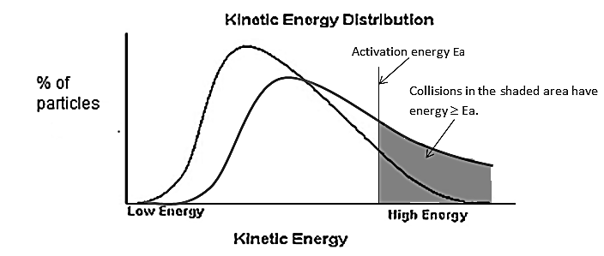

|  |  |
| --- | --- |
| **Description (of graph)** | **Marks** |
| New curved line must show lower peak and skew to the right and have a similar area under the curve to the original | 1 |
| The line for activation energy and shading need to be in the diagram (but not necessarily labelled if clearly referred to in the explanation below) | 1 |
| **Description (explanation)** | **Marks** |
| A higher temperature means an increase in the velocity of the particles which results in a larger % of collisions being successful | 1 |
| This is shown by the larger shaded area under the new (Ek distribution) curve and to the right of the line representing Ea (for this reaction) | 1 |

c) Explain, in terms of collision theory, how catalysts increase reaction rates. (3)

|  |  |
| --- | --- |
| **Description** | Marks |
| Catalysts provide an alternative pathway (from reactants to products) with lower activation energy | 1 |
| 2 marks for collision theory  A larger % of collisions have energy higher than the new lower activation energy  This leads to a higher % of successful collisions (and therefore an increased rate of reaction) | 1  1 |
| **Total** | 3 |

**Question 22 (7 marks)**

a) NaHCO3 + HCl →NaCl + H2O + CO2 (1)

b) n NaHCO3 = n CO2

= 0.01 (1)

MNaHCO3 = 84.0 (1)

m NaHCO3 = n x m = 0.84g (2SF) (1)

Many students didn’t notice the question giving measurement to only 2SF

c) particles of gas move faster at higher temperatures (1)

so they collide more often/harder with the water / exert more pressure (1)

causing the water to move down/the gas to expand (1)

**Question 23 (6 marks)**

a) Describe the appearance of the mixture. (2)

|  |  |
| --- | --- |
| **Description** | **Marks** |
| blue solution (liquid) and  (undissolved) (blue) crystals/solid | 1-2 |
| **Total** | 2 |

‘mixture’ was used in the question and many students used the word mixture in their answers which often made them unclear

There was a number of students who described a salmon pink solid or who thought that it would be a white or black colour! Remind them that this info is on their data sheets.

b) Describe any change(s) to the mixture. (1)

|  |  |
| --- | --- |
| **Description** | **Marks** |
| Crystals / solids dissolve | 1 |

Students describing the wrong colour had been penalised for that above. Solid dissolving was the only important feature here

c) Calculate the concentration of this solution in g L-1 and mol L-1. (assume no change in volume of solution occurs when copper sulfate dissolves in water). M(CuSO4.5H2O) = 249.70 g mol-1 (3)

|  |  |
| --- | --- |
| **Description** | **Marks** |
| **g L-1**  c(CuSO4.5H2O) = m/v = 5.00 / 0.0900 = 55.6 g L-1 (3SF) | 1 |
| **mol L-1**  n(CuSO4.5H2O) = m/M = 5.00/249.70 = 0.02002 mol (SF not required) | 1 |
| [CuSO4.5H2O] = n/v = 0.02002/0.0900 = 0.222 mol L-1 (3SF) | 1 |

If they got the SF wrong they were only penalised for one of the two.

If they’d done the mole calculation anywhere they were given a mark for it

As the question did not specifically say that hydrated copper sulfate was used, many students calculated for anhydrous CuSO4, which was also accepted. If they did that, the answers were:

n = 3.13 x 10-2mol (SF not important) and c = 0.348molL-1 (3SF)

It would be worth pointing out that hydrated copper sulfate info was given and that is what should have been used.

**Question 24 (10 marks)**

The diagram below shows some of the gases that enter and exit a catalytic converter.

CH4 catalytic CO2

NOx converter N2

CO H2O

(a) What is the function of a catalytic converter? (1 mark)

* **reduce pollutants like unburnt petrol, carbon monoxide and nitrous oxides emitted by car engines / converts poisonous substances like carbon monoxide and nitrous oxides into more harmless substances like carbon dioxide and nitrogen**

(b) Choose three (3) of the gases labelled in the diagram above and complete the following table by;

* drawing the structural formula for each molecule, representing all valence shell electron pairs either as : or –,
* naming the shape of the molecule, and
* stating the most significant intermolecular forces present in a pure sample.

**Each of your chosen gases must have a different molecular shape**. (9 marks)

|  |  |  |
| --- | --- | --- |
| Electron dot diagram | Shape | Intermolecular forces |
|  | **tetrahedral** | **dispersion** |
|  | **v-shaped / bent** | **hydrogen bonds** |
| **. C . O**  **xx**  **x x**  **x x**  **. .** | **linear** | **dispersion**  **dispersion**  **dipole-dipole** |

**1 mark for each correct box (They cannot repeat the last 3 gases mark only the first gas if they do**

**Question 25 (7 marks)**

a) Describe the type of bonding in the element magnesium (4)

|  |  |
| --- | --- |
| **Description** | **Marks** |
| Magnesium’s bonding is metallic | 1 |
| Magnesium has positive ions  Surrounded by delocalised electrons | 1-2 |
| delocalised valence electrons are electrostatically attracted to metal ions. | 1 |
| **Total** | 4 |

b) Describe the trend in valency for the Period 3 elements. (2)

|  |  |
| --- | --- |
| **Description** | **Marks** |
| Valency increases from Na (1) to Si (4) then decreases from Si to Ar (0)  **Only 1 mark if rising and then falling is not clearly described** | 1-2 |
| **Total** | 2 |

**Question 26 (10 marks)**

a) Label the pieces of equipment (1,2) and the chemicals (3,4). (4)

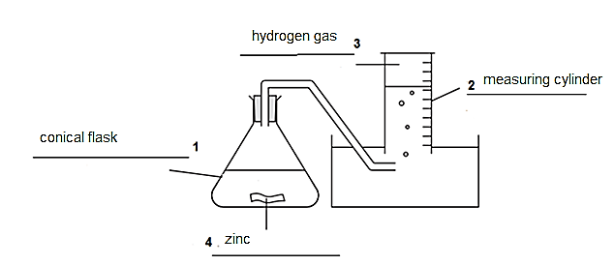

|  |  |
| --- | --- |
| **Description** | **Marks** |
| 1 mark per correct label  Accept Erlenmeyer flask for conical flask | 1-4 |
| **Total** | 4 |

b) Draw a suitable graph of these results on the grid below. (4)

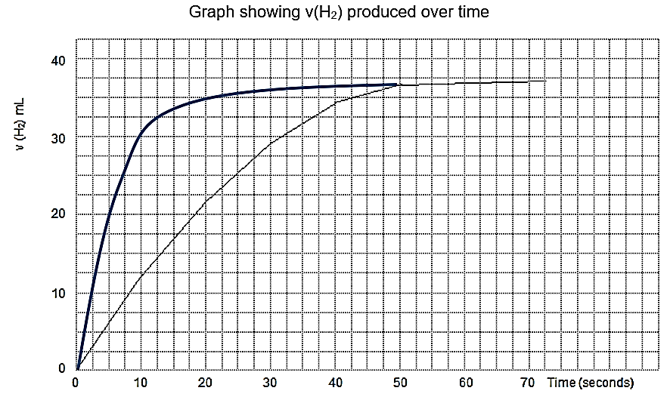

|  |  |
| --- | --- |
| **Description** | **Marks** |
| Correctly numbered and labelled axes (-1 if axis wrong way around) | 1-2 |
| Correctly drawn smooth curve through the correctly plotted points (-1 if dot to dot) | 1-2 |
| **Total** | 4 |

c) Sketch the shape of the graph for this experiment using the same axes as part (b). (2)

|  |  |
| --- | --- |
| **Description** | **Marks** |
| Starts and finishes at the same points as first graph | 1 |
| Significantly steeper gradient | 1 |
| **Total** | 2 |

**Question 27 (6 marks)**

a) Draw a Lewis structure (electron dot diagram) for chloromethane. (2)

|  |  |
| --- | --- |
| **Description** | **Marks** |
| Pairs of dots may be drawn to represent bonds between carbon and hydrogen. Must show all electrons around Cl or zero | 1 |
| **Total** | 1 |

b) Name (or draw) the shape of chloromethane and state whether it is a polar or non-polar molecule. (2)

|  |  |
| --- | --- |
| **Description** | **Marks** |
| Tetrahedral (or shape drawn and recognisable as tetrahedral) | 1 |
| Polar (molecule) | 1 |
|  |  |

c) Complete the Lewis structure for sodium chloride below and state the electron configuration for each ion underneath its symbol. (3)

|  |  |
| --- | --- |
| **Description** | **Marks** |
| 1 mark for correctly drawn electron pairs around chloride and Na+  1 mark for each electron configuration |  |
| **Total** | 3 |

**Question 28 (6 marks)**

a) Benzene reacts with limited aqueous chlorine (Cℓ2 (aq)) in the presence of UV light.

Write and balance a molecular equation. (1)

|  |  |
| --- | --- |
| **Description** | **Marks** |
| C6H6 + Cℓ2 → C6H5Cℓ + HCℓ | 1 |

Name and draw a full structural formula (showing all bonds and all atoms) of the main organic product. (2)

|  |  |
| --- | --- |
| **Description** | **Marks** |
| chlorobenzene | 1 |
| or | 1 |

-1 if Hydrogens are not drawn in or if aromatic circle is deleted

Pay 2 if addition reaction is shown **and** product named and drawn as 1,2 dichlorobenzene a

b) But-2-ene gas reacts with aqueous bromine (Br2(aq)).   
Write and balance a molecular equation. (1)

|  |  |
| --- | --- |
| **Description** | **Marks** |
| C4H8 + Br2 → C4H8Br2 | 1 |

Name and draw a full structural formula (showing all bonds and all atoms) of the main organic product. (2)

|  |  |
| --- | --- |
| **Description** | **Marks** |
| 2,3-dibromobutane | 1 |
|  | 1 |

Pay 1 if 1,1 dibromobutane or similar is named and drawn. Nb Named and drawn structures must match and can not simplify the question.

**End of Section Two**

**Section Three: Extended answer 40% (80 Marks)**

For all calculations, there may be other valid methods for obtaining the correct answer.Accept all methods that have clear and logical reasoning.

**Question 29 (20 marks)**

a) Write a balanced chemical equation for the decomposition of sodium azide. (2)

|  |  |
| --- | --- |
| **Description** | **Marks** |
| 2 NaN3 (s) → 2 Na (s) + 3 N2 (g) |  |
| Correct species | 1 |
| Correct balancing and states | 1 |
| **Total** | 2 |

b) Why is it necessary to absorb the sodium metal produced? (1)

|  |  |
| --- | --- |
| **Description** | **Marks** |
| Answer could include:  can burn (at the high temperatures of the airbag ignition)  can explode on contact with air (oxygen)  (rapidly reacts with any moisture and) can produce (caustic) sodium hydroxide | 1 |
| **Total** | 1 |

Formation of a metallic solid and it being dangerous was not marked correct. The solid formed would be a very fine dust/powder and not a lump of metallic solid.

c) Explain the dissolving process of solid ammonium nitrate in water in terms of   
(i) bonds broken or formed and   
(ii) energy and temperature changes in the system. (6)

|  |  |  |
| --- | --- | --- |
| **Description** | | **Marks** |
| (i) | Ionic bonds between ammonium and nitrate ions break apart (in water) | 1 |
| Hydrogen bonds between water molecules break apart (to accommodate the dissolved ions) | 1 |
| Ion-dipole bonds form between water molecules and the (individual ammonium and nitrate) ions | 1 |
|  | **Total** | 3 |

|  |  |  |
| --- | --- | --- |
| **Description** | | **Marks** |
| (Ii) | Energy is required to beak ionic bonds (endothermic process) | 1 |
| Energy is given out when new ion-dipole bonds are formed (exothermic process) | 1 |
| Energy required was greater than the energy given out (as the overall process of dissolving ammonium nitrate is endothermic) the temperature decreases | 1 |
|  | **Total** | 3 |

d) Draw an energy profile diagram for this decomposition reaction labelling

reactants and products

activation energy (Ea)

transition state (activated complex)

heat of reaction (∆H) (5)

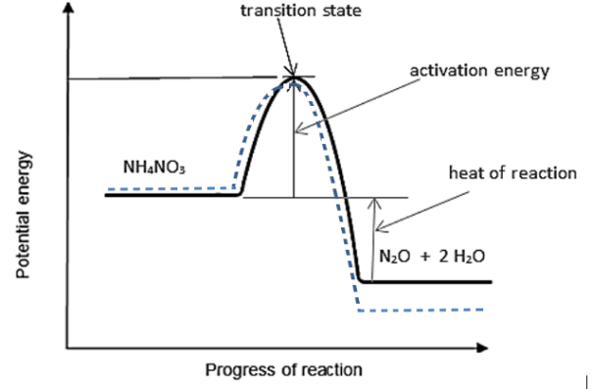

|  |  |
| --- | --- |
| **Description** | **Marks** |
| General shape of energy profile correct. | 1 |
| **1 mark per clearly identified label including**  both reactant and products labelled for 1 mark  size and position of activation energy clearly shown  transition state identified  size and position of heat of reaction clearly shown | 1-4 |
| **Total** | 5 |

e)

|  |  |
| --- | --- |
| @STP n (gas) = V/22.71 = 40.0/22.71 = 1.76 mol | 1 |
| Recognition that reaction produced two gaseous products (N20 and H20) | 1 |
| n (NH4NO3) = 1/3 x n(gas) = 1/3 x 1.76 = 0.587 mol | 1 |
| m (NH4NO3) = n x M = 0.5873 x 80.052 = 47.0 g | 1 |

f) Manipulated **Amount of water absorbed (1)**

Controlled **Amount of NH4NO3**, (1)

There could be other realistic variables suggested

**Question 30 (11 marks)**

a) Calculate the mass of TiO2, in kilograms, that could be extracted from 109000 tonnes of ilmenite. M((FeO.TiO2) = 151.73 g mol-1 M(TiO2) = 79.88 g mol-1 (3)

|  |  |
| --- | --- |
| **Description** | **Marks** |
| n(FeO.TiO2) = m/M = 109000 x 106 /151.73 = 7.184 x 108 mol | 1 |
| n(TiO2) = n(FeO.TiO2) = 7.184 x 108 mol | 1 |
| m(TiO2) = n x M = 7.184 x 108 x 79.88 = 5.738 x 1010 g |  |
| m(TiO2) in kilograms = 5.738 x 107 kg | 1 |
| **Total** | 3 |

c) Calculate the mass of titanium dioxide that can be produced per kilogram of ilmenite in this stage. (4)

|  |  |
| --- | --- |
| **Description** | **Marks** |
| n(FeO**.**TiO2) = m/M = 1000 / 151.73 = 6.591 mol | 1 |
| n(TiO2) = 2/4 x n(FeO**.**TiO2) | 1 |
| = 2/4 x 6.591 = 3.295 mol | 1 |
| m(TiO2) = n x M = 3.295 x 79.88 = 263.2 g | 1 |
| **Total** | 4 |

d) Balance the equation. (2)

|  |  |
| --- | --- |
| **Description** | **Marks** |
| Fe2O3**.**TiO2(s) + 3 CO(g) → 2 Fe(s) + TiO2(s) + 3 CO2(g) |  |
| Correct coefficients (one mark if ratio’s are not simplified) | 2 |

e) Calculate the percentage of titanium metal in ilmenite. (2)

|  |  |
| --- | --- |
| **Description** | **Marks** |
| % Ti = M(Ti) / M(FeO**.**TiO2) x 100 | 1 |
| = 47.88/151.73 x 100 = 31.56 % | 1 |
| **Total** | 2 |

**Question 31 (12 marks)**

Several different brands of sports drinks were analysed by atomic absorption spectroscopy (AAS) to determine their sodium content. Sports drinks contain sodium in the form of sodium ions, Na+. A diagram of the equipment used in AAS is shown below.

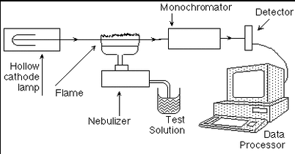

In this analysis, the element in the hollow cathode lamp contained sodium (Na). When the lamp is turned on, the atoms of sodium produce an emission spectrum that is unique to the sodium element.

(a) Explain how sodium atoms are able to produce this unique emission spectrum. (3 marks)

* **when electrons absorb energy they are able to move up to a higher energy level (the electrons moves from the ground state to ‘excited’)**
* **as the electrons move to a lower energy level (their original level) they release the energy again**
* **this energy produces the emission spectrum which is made up of a particular set of frequencies/wavelengths that are unique to each element**

Samples of each sports drink were diluted with water and then run through the spectrometer. Absorbance values for each were collected. The data was then compared to an existing calibration curve for sodium, which is shown below.

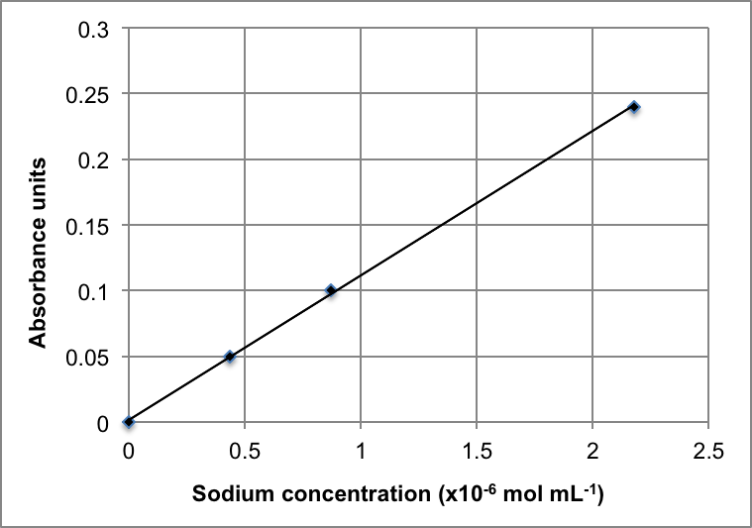

(b) Describe how this calibration curve would have been obtained. (3 marks)

* **Na standards / solutions with a known Na concentration**
* **Would have been run through the AAS to measure their absorbance**
* **These absorbance values would have been plotted and then a line of best fit drawn**

Using the calibration curve above, the concentration for a particular diluted sports drink was determined to be 1.11 x 10-6 mol mL-1.

(c) What absorbance would this correspond to? (1 mark)

* **accept 0.12 to 0.13**

A 10.00 mL sample of a sports drink was taken and diluted to a final volume of 250.0 mL by the addition of water. A portion of the dilute sample was analysed by AAS.



sample diluted to 250.0 mL with water

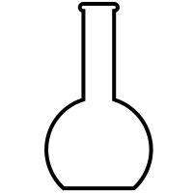

10.00 mL sample of sports drink taken

dilute sample analysed by AAS

The absorbance obtained was compared to the calibration curve and the concentration was determined to be 1.11 x 10-6 mol mL-1 as previously stated.

(e) Calculate the concentration of sodium (in mol L-1) in the **undiluted** sports drink. (3 marks)

**c(Na+) = 1.11 x 10-6 mol mL-1 = 1.11 x 10-6 x 103 = 1.11 x 10-3 mol L-1 (1)**

**c1 = c2V2 / V1**

**= (1.11 x 10-3 x 0.250 ) / 0.010**

**= 0.027729 mol L-1**

**i.e. concentration of Na+ in sports drink is 0.0277 mol L-1 (3 SF) (2)**

**OR**

**n(Na+ in 250 mL) = cV**

**= 1.11 x 10-3 x 0.25**

**= 0.000277295 mol**

**= n(Na+ in 10 mL sample) (1)**

**c(Na+ in 10 mL) = n/V**

**= 0.000277295 / 0.010**

**= 0.027729 mol L-1**

**i.e. concentration of Na+ in sports drink is 0.0277 mol L-1 (3 SF) (1)**

The sports drink was sold in a 600 mL bottle.

(f) Calculate the total mass of sodium present in the drink. (2 marks)

**n(Na+) = cV**

**= 0.027729 x 0.600**

**= 0.01663767 mol (1)**

**m(Na+) = nM**

**= 0.01663767 x 22.99**

**= 0.3825 g**

**= 0.383 g (3 SF) (1)**

**Question 32 (12 marks)**

a) With the aid of relevant balanced **ionic** equations justify their conclusion. (6)

|  |  |
| --- | --- |
| **Description** | **Marks** |
| Na2CO3(s) + 2 H+(aq) → 2 Na+(aq) + H2O(ℓ) + CO2(g)  Statements may include:  white powder implies an ionic compound  fizzing with hydrochloric acid implies a gas produced and therefore likely to be a carbonate must mention carbonates able to produce a gas  a white, soluble carbonate implies it could be a sodium or potassium compound  No marks were given if the students just rewrote the question and didn’t give any additional information to justify conclusions | 1-2  1  1 |
| CO32-(aq) + Cu2+(aq) → CuCO3(s)  Green precipitate = copper (II) carbonate  Statements/equations about nickel are less relevant as all nickel salts are green | 1  1 |
| **Total** | 6 |

b) Calculate the minimum volume of 2.00 mol L-1 hydrochloric acid required to react completely with the 2.00 g of sodium carbonate. (3)

|  |  |
| --- | --- |
| **Description** | **Marks** |
| M(Na2CO3) = 105.99 g mol-1 |  |
| n(Na2CO3) = m/M = 2.00/105.99 = 0.01887 mol | 1 |
| n(HCℓ) = 2 x n(Na2CO3) = 2 x 0.01887 = 0.03774 mol | 1 |
| v(HCℓ) = n / c = 0.03774 / 2.00 = 0.0189 L (or 18.9 mL) | 1 |
| **Total** | 3 |

c) Calculate the number of moles of sodium carbonate in the 20.0 mL sample in test (iii) (3)

|  |  |  |
| --- | --- | --- |
| **Description** (other methods possible) | **Marks** |  |
| n(Na2CO3) in 20.0 g sample = m/M = 20/105.99 = 0.1887 mol (in 100 mL) | 1 |  |
| n(Na2CO3) in 20 mL sample = 20.0/100 x 0.1887 = 0.0377 mol **(3 SF)** | 1  1 |  |

Question 33 (12 marks)

A chemistry student has a solution of silver nitrate, AgNO3(aq), with a labelled concentration of 0.0425 g mL-1. The student measured out 75.0 mL of the AgNO3(aq) and placed it in a beaker.

(a) Calculate the concentration of the AgNO3(aq) solution in moles per litre. (2 marks)

**c = 0.0425 g per mL = 0.0425 x 103 g per L = 42.5 g in 1 L (1)**

**n(AgNO3 in 1 L) = m/M**

**= 42.5 / 169.91**

**= 0.250132 mol**

**i.e. c(AgNO3) = 0.250 mol L-1 (3 SF) (1)**

The student then added 100.0 mL of 0.12 mol L-1 sodium carbonate solution, Na2CO3(aq). They ensured there was excess Na2CO3(aq) present in order to precipitate all the silver ions from solution.

The equation for the reaction that took place is;

2 AgNO3(aq) + Na2CO3(aq) → Ag2CO3(s) + 2 NaNO3(aq)

(b) State the observations that would have been made as the reaction took place.(2 marks)

* **2 clear colourless solutions mix (1)**
* **a yellow precipitate forms (1)**

(c) Calculate the concentration of sodium ions, Na+(aq), that would be present after the two solutions were mixed. (4 marks)

**n(Na2CO3) = cV**

**= 0.12 x 0.1**

**= 0.012 mol (1)**

**n(Na+) = 2 x n(Na2CO3)**

**= 0.024 mol (1)**

**V(total) = 0.175 L (1)**

**c(Na+) = n/V**

**= 0.024 / 0.175**

**= 0.13714 mol L-1 (1)**

**= 0.14 mol L-1 (2 SF)**

(e) Calculate the mass of Ag2CO3(s) precipitate, once dried, that would have been separated from this mixture. (3 marks)

**n(AgNO3) = cV**

**= 0.250132 x 0.075**

**= 0.0187599 mol (1)**

**n(Ag2CO3) = n(AgNO3) / 2**

**= 0.0187599 / 2**

**= 0.00937995 mol (1)**

**m(Ag2CO3) = nM**

**= 0.00937995 x 275.81**

**= 2.58708 g**

**= 2.59 g (3 SF) (1)**

(f) Name the two (2) solids that would have been present on the evaporating dish. (1 mark)

* **NaNO3 (the product) and Na2CO3 (the excess reagent) (1)**

Must have both

**End of questions**